Bài giữa kì
Tên: Hà Minh Tiến
Lớp: CNTT4
Mssv:1250080194
Đề tài: quản lí thuê 1 vị trí bán hàng ở hội chợ

Mục tiêu đề tài
- Thiết kế CSDL Oracle cho bài toán quản lý
- Xây dựng ứng dụng WinForms kết nối Oracle
- Thực hiện các thao tác thêm – sửa – xóa – xem dữ liệu
- Áp dụng phân quyền người dùng
Công nghệ sử dụng
- Oracle Database
- SQL Developer
- Visual Studio
- WinForms (.NET)
- Oracle Managed Data Access

Source code csdl:
-- T?o user m?i
CREATE USER app IDENTIFIED BY matkhau
DEFAULT TABLESPACE users
TEMPORARY TABLESPACE temp
QUOTA UNLIMITED ON users;

-- C?p quy?n c? b?n
GRANT CREATE SESSION TO app;
GRANT CREATE TABLE TO app;
GRANT CREATE VIEW TO app;
GRANT CREATE SEQUENCE TO app;
GRANT CREATE TRIGGER TO app;
GRANT CREATE PROCEDURE TO app;

-- 1) KHÁCH HÀNG
CREATE TABLE KHACH_HANG (
MA_KH VARCHAR2(10) PRIMARY KEY,
TEN_KH VARCHAR2(100) NOT NULL,
LOAI_KH VARCHAR2(50) CHECK (LOAI_KH IN ('Ho kinh doanh','Xi nghiep','Cong ty')),
SDT VARCHAR2(15),
EMAIL VARCHAR2(100)
);

-- 2) V? TRÍ
CREATE TABLE VI_TRI (
MA_VT VARCHAR2(10) PRIMARY KEY,
KHU_VUC VARCHAR2(50) NOT NULL,
DIEN_TICH NUMBER CHECK (DIEN_TICH > 0),
NOI_THAT VARCHAR2(100),
CO_DIEN CHAR(1) DEFAULT 'N' CHECK (CO_DIEN IN ('Y','N')),
CO_NUOC CHAR(1) DEFAULT 'N' CHECK (CO_NUOC IN ('Y','N'))
);

-- 3) THUÊ
CREATE TABLE THUE (
MA_THUE VARCHAR2(10) PRIMARY KEY,
MA_KH VARCHAR2(10) NOT NULL,
MA_VT VARCHAR2(10) NOT NULL,
NGAY_BAT_DAU DATE NOT NULL,
NGAY_KET_THUC DATE NOT NULL,
CHI_PHI NUMBER CHECK (CHI_PHI >= 0),
PHUONG_THUC_TT VARCHAR2(50) CHECK (PHUONG_THUC_TT IN ('Tien mat','Chuyen khoan','The')),
CONSTRAINT FK_THUE_KH FOREIGN KEY (MA_KH) REFERENCES KHACH_HANG(MA_KH),
CONSTRAINT FK_THUE_VT FOREIGN KEY (MA_VT) REFERENCES VI_TRI(MA_VT),
CONSTRAINT CK_THUE_NGAY CHECK (NGAY_KET_THUC >= NGAY_BAT_DAU)
);

-- 4) S? C?
CREATE TABLE SU_CO (
MA_SC VARCHAR2(10) PRIMARY KEY,
MA_THUE VARCHAR2(10) NOT NULL,
NOI_DUNG VARCHAR2(200),
BIEN_PHAP VARCHAR2(200),
KET_QUA VARCHAR2(100),
CONSTRAINT FK_SC_THUE FOREIGN KEY (MA_THUE) REFERENCES THUE(MA_THUE)
);

-- 5) THANH TOÁN
CREATE TABLE THANH_TOAN (
MA_TT VARCHAR2(10) PRIMARY KEY,
MA_THUE VARCHAR2(10) NOT NULL,
NGUOI_TRA VARCHAR2(100),
NGUOI_NHAN VARCHAR2(100),
TIEN NUMBER CHECK (TIEN >= 0),
KET_QUA VARCHAR2(50) CHECK (KET_QUA IN ('Hoan tat','Con no','Den bu')),
CONSTRAINT FK_TT_THUE FOREIGN KEY (MA_THUE) REFERENCES THUE(MA_THUE)
);

CREATE ROLE nhanvien;
GRANT SELECT ON KHACH_HANG TO nhanvien;
GRANT SELECT ON VI_TRI TO nhanvien;
GRANT SELECT, INSERT, UPDATE ON THUE TO nhanvien;
GRANT SELECT ON SU_CO TO nhanvien;
GRANT SELECT ON THANH_TOAN TO nhanvien;

CREATE USER nv IDENTIFIED BY matkhau;
GRANT CONNECT TO nv;
GRANT nhanvien TO nv;

CREATE ROLE quanly;
GRANT SELECT, INSERT, UPDATE, DELETE ON KHACH_HANG TO quanly;
GRANT SELECT, INSERT, UPDATE, DELETE ON VI_TRI TO quanly;
GRANT SELECT, INSERT, UPDATE, DELETE ON THUE TO quanly;
GRANT SELECT, INSERT, UPDATE, DELETE ON SU_CO TO quanly;
GRANT SELECT, INSERT, UPDATE, DELETE ON THANH_TOAN TO quanly;

CREATE USER ql IDENTIFIED BY matkhau1;
GRANT CONNECT TO ql;
GRANT quanly TO ql;

INSERT INTO KHACH_HANG VALUES ('KH01','Cong ty ABC','Cong ty','0901234567','abc@gmail.com');
INSERT INTO KHACH_HANG VALUES ('KH02','Ho KD Minh','Ho kinh doanh','0939876543','minh@hkdm.vn');

INSERT INTO VI_TRI VALUES ('VT01','Khu A',20,'Ban ghe','Y','Y');
INSERT INTO VI_TRI VALUES ('VT02','Khu B',12,'Quay nho','N','Y');

INSERT INTO THUE VALUES ('T01','KH01','VT01',DATE '2026-02-01',DATE '2026-02-07',5000000,'Chuyen khoan');
INSERT INTO THUE VALUES ('T02','KH02','VT02',DATE '2026-02-03',DATE '2026-02-05',2000000,'Tien mat');

INSERT INTO SU_CO VALUES ('SC01','T01','Mat dien 2h','Cap may phat','Da khoi phuc');
INSERT INTO THANH_TOAN VALUES ('TT01','T01','Cong ty ABC','Ban to chuc',5000000,'Hoan tat');

-- Trên site A (mi?n B?c) t?o link t?i site B (mi?n Nam)
DROP DATABASE LINK site_nam;

CREATE DATABASE LINK site_nam
CONNECT TO app IDENTIFIED BY matkhau
USING '(DESCRIPTION=(ADDRESS=(PROTOCOL=TCP)(HOST=localhost)(PORT=1521))(CONNECT_DATA=(SERVICE_NAME=haminhtien1250080194)))';

-- Truy v?n d? li?u t? site mi?n Nam
SELECT * FROM KHACH_HANG@site_nam;

-- T?i site A (mi?n B?c): l?u Khu A
CREATE TABLE VI_TRI_KHU_A AS
SELECT * FROM VI_TRI WHERE KHU_VUC = 'Khu A';

-- T?i site B (mi?n Nam): l?u Khu B
CREATE TABLE VI_TRI_KHU_B AS
SELECT * FROM VI_TRI WHERE KHU_VUC = 'Khu B';

CREATE TABLE KHACH_HANG_LIEN_HE AS
SELECT MA_KH, SDT, EMAIL FROM KHACH_HANG;

CREATE TABLE KHACH_HANG_DINH_DANH AS
SELECT MA_KH, TEN_KH, LOAI_KH FROM KHACH_HANG;

SELECT * FROM SYS.KHACH_HANG@SITE_NAM;
CSDL phân tán và phân mảnh
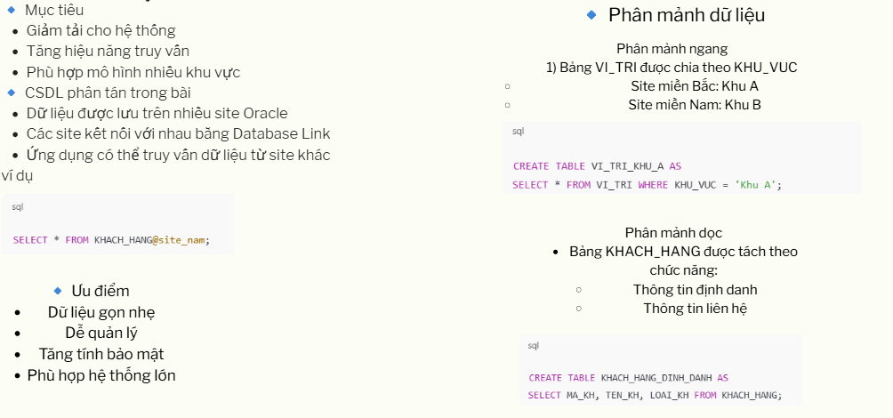
Phân quyền
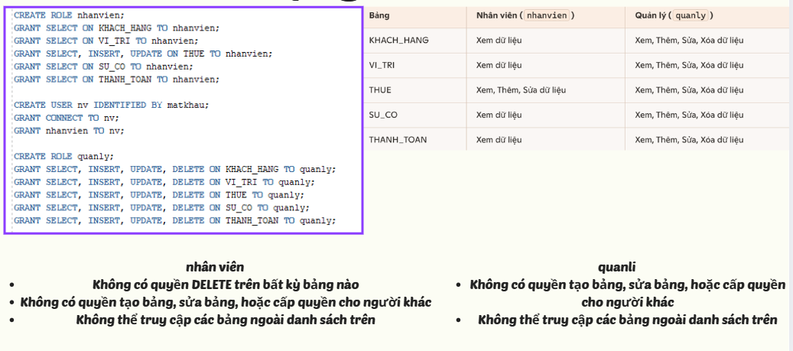
Ràng buộc và khóa
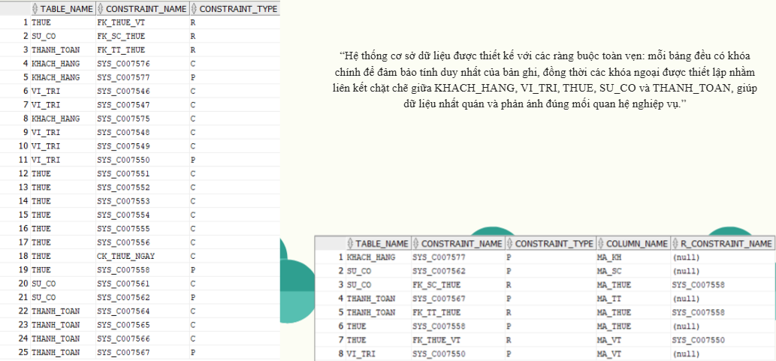

Mô hình hệ thống
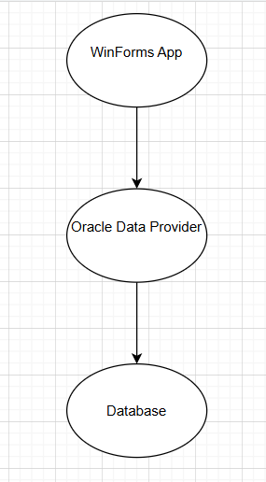
“Ứng dụng WinForms kết nối trực tiếp tới Oracle thông qua thư viện Oracle Managed Data Access.”
Thiết kế CSDL
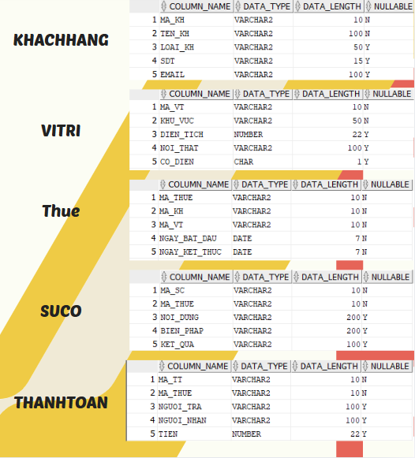

Giao diện ứng dụng
